User guide

Contents

Setup 1

Operation 4

Retrieval Mode 4

Sampling Mode 5

Locate Mode 6

Diagnostic Mode 6

Status Mode 7

# Setup

WaveSphere consists of two parts: the spheres (drifters) and the base station (computer). The spheres need to have their batteries charged in order for the system to operate properly. In order to use the system, first plug the Xbee Explorer dongle into the base station computer. Once connected, you can proceed to run WaveSphere.jar. When the GUI opens, the first window that appears looks like the one shown in Figure 1. You will need to select, from the list, the port associated with the Xbee.

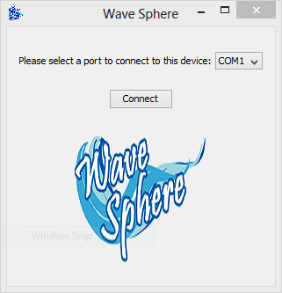

Figure 1: Main Window

After getting connected, you will see a window like the one shown in Figure 2. You need to add the spheres you will use for this experiment in order to proceed. Press the Add New Sphere button to proceed.

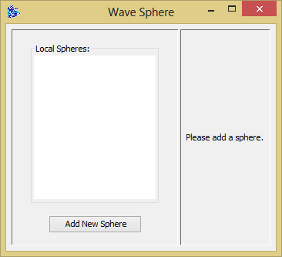

Figure 2: Window without spheres

After clicking the Add New Sphere button, a form for adding a new sphere, like the one shown in Figure 3, appears. The ID needs to be in the form XXX-XXXX, where Xs are one digit numbers (0-9) and the name can be any string, as shown in Figure 4. You can continue adding spheres until you press cancel.

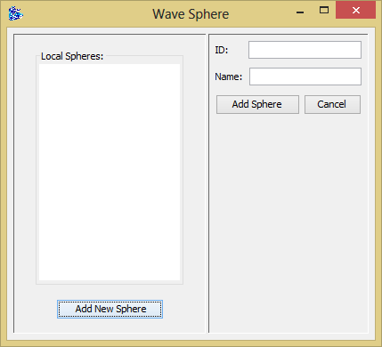

Figure 3: Add New Sphere blank

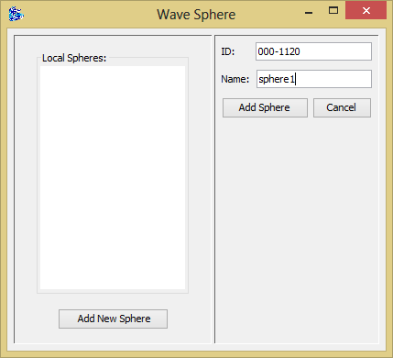

Figure 4: Add New Sphere Example

After adding the sphere, it will appear in the list on the left, as shown in Figure 5.

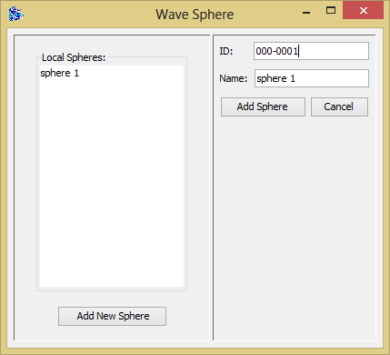

Figure 5: Window with added spheres

In order to manage a sphere, you need to select one from the list. Then you can proceed to initiate the different modes (retrieval, sampling, diagnostic or shutdown). Make sure you have turned on the desired sphere by passing the RFID reader to the sphere. If you fail to do so, the GUI will not work properly.

# Operation

## Retrieval Mode

When Retrieval Mode is selected, a save dialog appears (as shown in Figure 6). You will need to select a location and a name for your text file (make sure to include the desired extension: .txt for example).

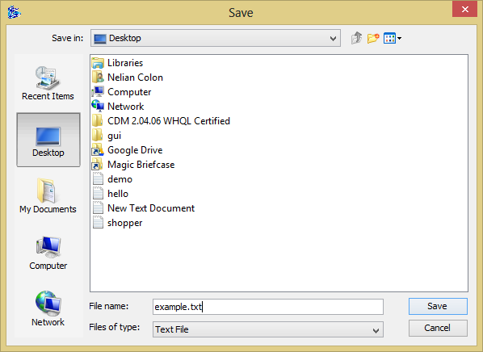

Figure 6: Save Dialog - Retrieval Mode

**Do not proceed** until you see a dialog stating that the file was saved, as shown in Figure 7. Otherwise, data will be corrupted.

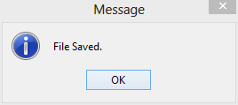

Figure : File Saved

## Sampling Mode

When sampling mode is selected, the GUI will enter into a waiting screen as shown in Figure 8.

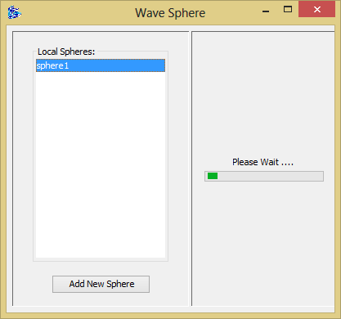

Figure 8: Sampling Mode

## Locate Mode

After finishing sampling, you can proceed to locate your sphere. Locate mode will look as the one shown in Figure 9.

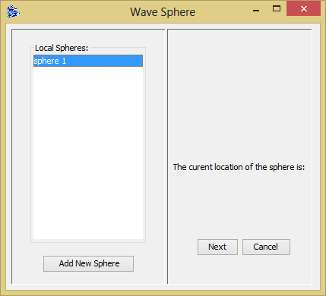

Figure 9: Locate Mode

Location will be shown until the exit button is pressed or until the next button after the last sphere’s location has been shown.

## Diagnostic Mode

When the diagnostic mode is selected, the right panel changes into diagnostic mode. Figure 10 shows how it looks like.

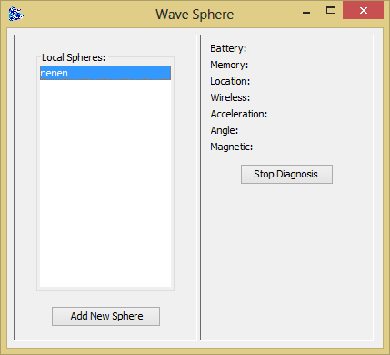

Figure 10: Diagnostic Mode

## Status Mode

Whenever a sphere is selected and exits from other mode (Sampling, Retrieval, Diagnostic or Locate), the GUI will enter in Status Mode. Status Mode, as shown in Figure 11, shows the ID of the selected sphere, the memory available and the battery level.

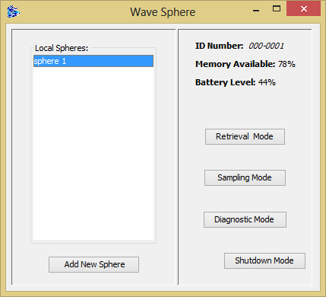

Figure : Status Mode